
Institute of Technology of Cambodia
Department of Applied Mathematics and Statistic
Group: I3-AMS-03
Subject: Advance Probability
Topic: Analyzing the factors that affect customer satisfaction in the airline industry using ordinal logistic regression Name: ID:
Tang Piseth e20201634
Kry Senghort e20200706
Sao Samarth e20200084
Hon Rathana e20201053
Pheng Sothea e20201734
Ek Vong Panharith e20200877
Table of contents:
1.
Project Description and Objectives 2.
Dataset and Variables Description 3.
Data Preparation
4.
Exploratory Data Analysis(EDA) 5.
Feature Engineering
6.
Model Selection
7.
Decision Making
I.) Project Description and Objectives
Airline Industry is the field of journey tourism or visiting to any places by using airline for travelling from one place to another one. On the other hand, We choose this topic beacause we want to use logistic linear regression to interpret and make prediction the result of satisfaction or disatifaction of passenger on airline industry. We will study on the variable that make effect to satisfaction or disatisfaction of customer.

2). Dataset and Variables Description
There are two data sets such as : test.csv and train.csv. There exist 129879 rows with 24 columns. There exists 24 variables as following:
Gender (object)
Customer Type (object)
Age (int64)
Type of Travel (object)
Class (object)
Flight Distance (int64)
Inflight wifi service (int64)
Departure/Arrival time convenient (int64) Ease of Online booking (int64)
Gate location (int64)
Food and drink (int64)
Online boarding (int64)
Seat comfort (int64)
Inflight entertainment (int64)
On-board service (int64)
Leg room service (int64)
Baggage handling (int64)
Checkin service (int64)
Inflight service (int64)
Cleanliness (int64)
Departure Delay in Minutes (int64) Arrival Delay in Minutes (float) Satisfaction (object)(target variable)
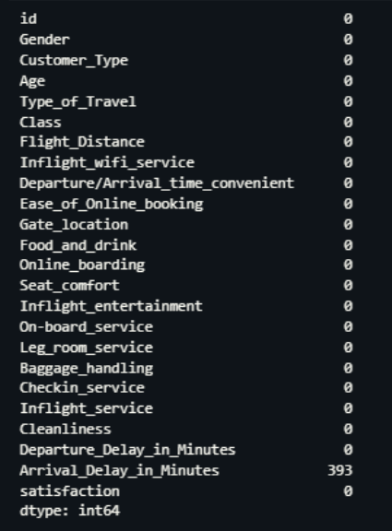
3). Data Preparation
After checking to our dataset we observe that there exist some missing values and also we decide to handle it by substituting with the mean values for numerical variable and mode for the categorical variables. As the result, feature "Arrival_Delay_in_Minutes" existing 393 missing values.
Descriptive Statistics Before Handle Missing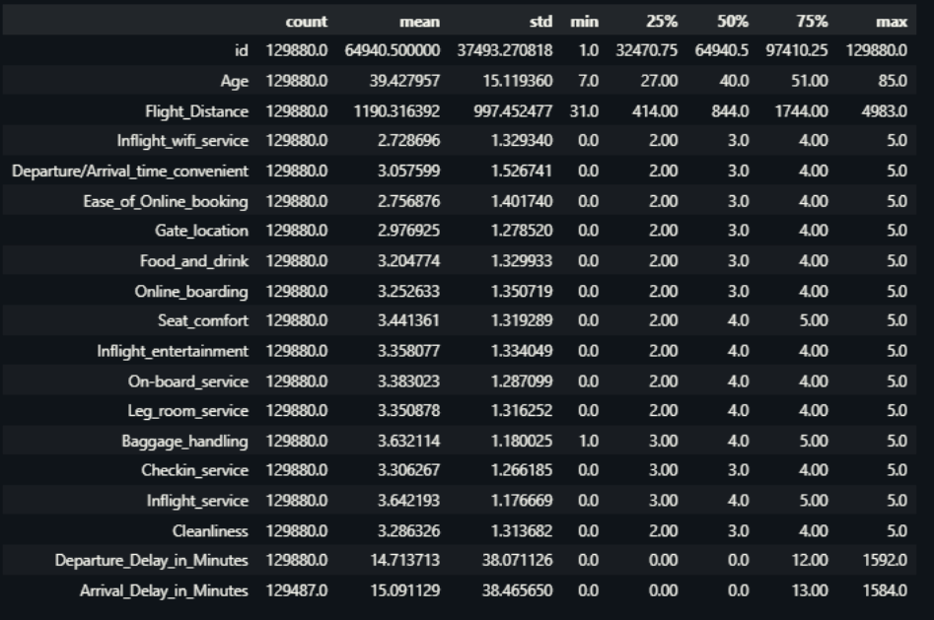
4). Exploratory Data Analysis (EDA)
Statistic Table
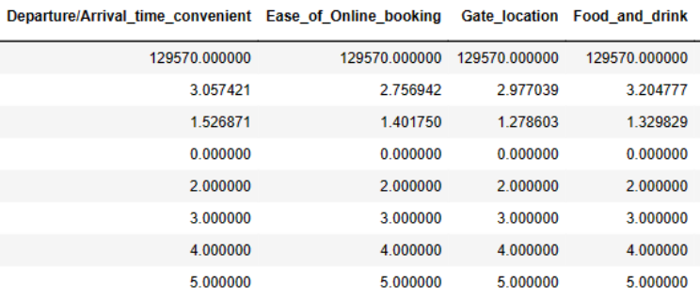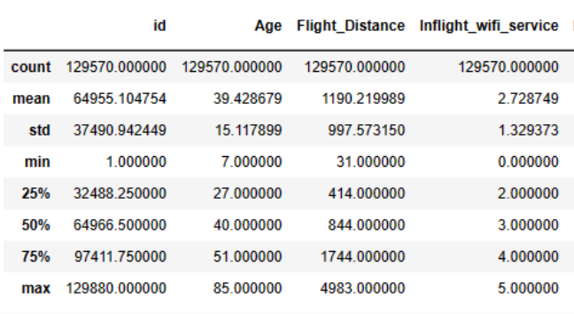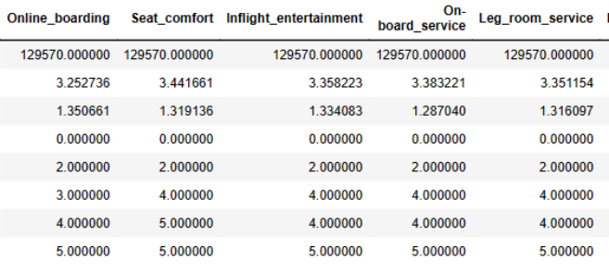
Heat map
Box plot
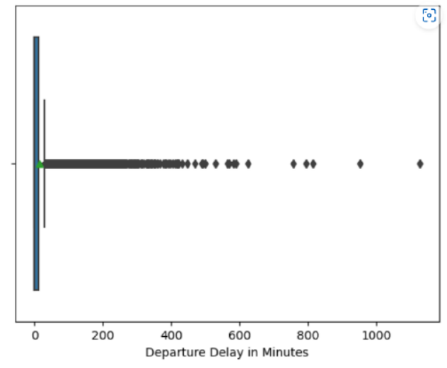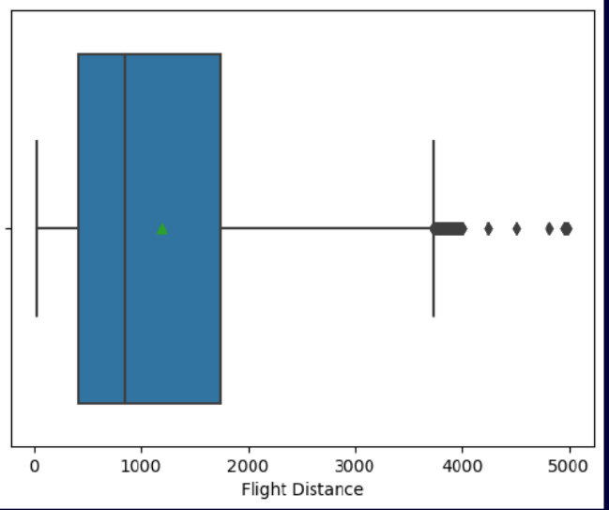

Bar graph
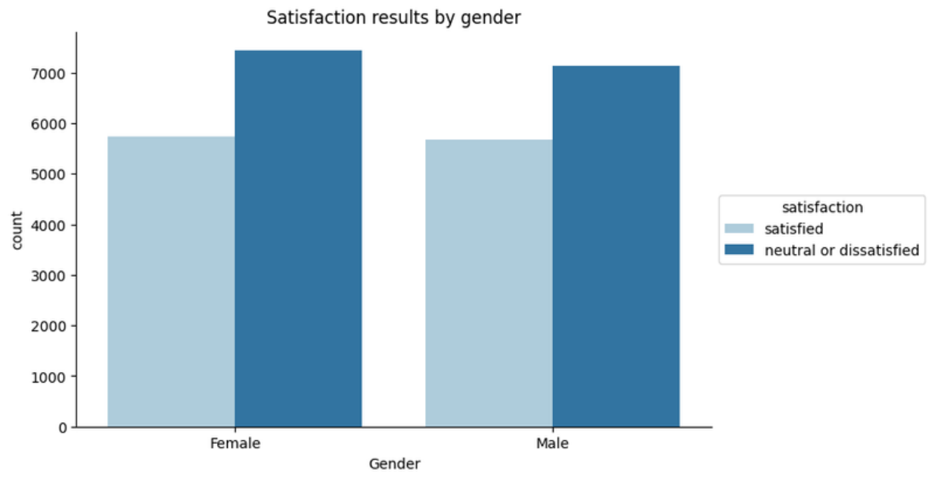
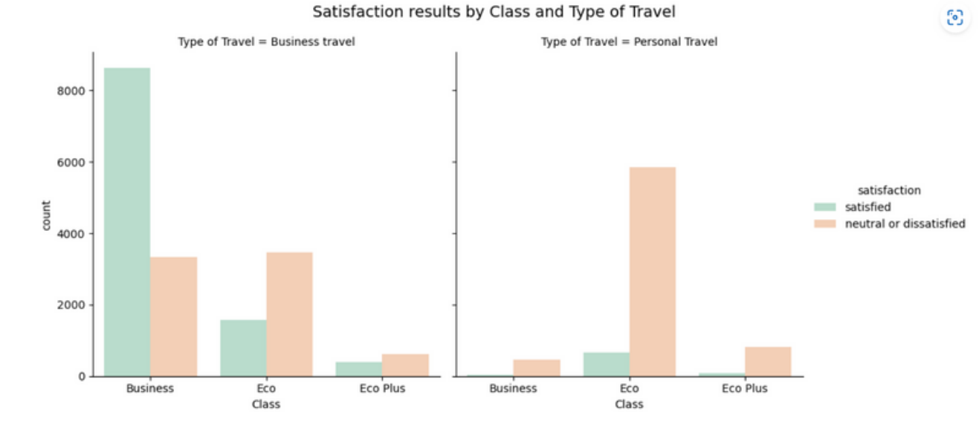
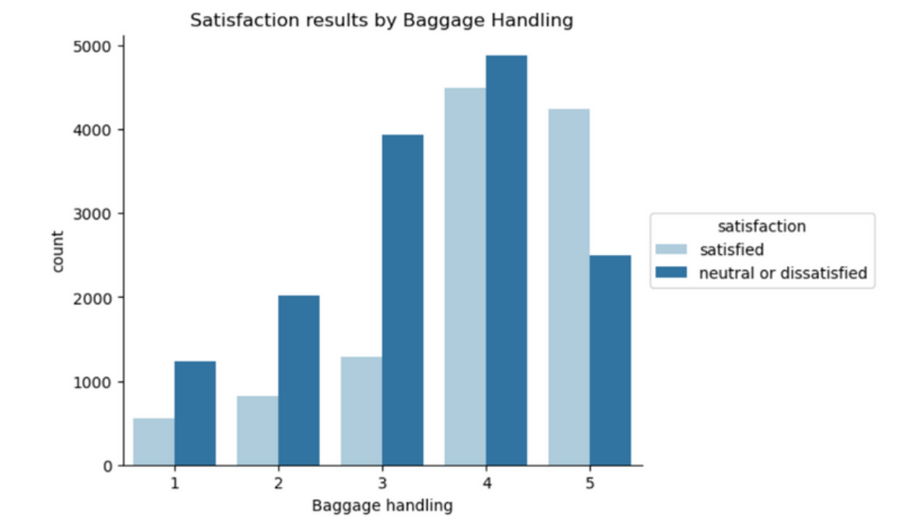
Pair pot
Pie chat
5). Feature Engineering 5.1). Encoding Categorical Variables
In classification problems, the goal is to predict the category of a new observation based on a set of training data. However, machine learning algorithms cannot directly work with categorical variables. They can only work with numerical data. Therefore, it is necessary to encode categorical variables into numerical values before they can be used in a classification model.
5.2). Feature Selection and Feature Importance
Setting our categorical
& target variable
Feature Selection by Chi-Sqaure
Test
Feature Importance by
Wrapper Method
(random forest)
Feature Importance by
Permutation Method
Feature Importance by Decision Tree
Feature Importance by
Recursive Feature Elimination
5.3).Dimentionality Reduction
PerformModel Algorithm
Linear regression analysis
satisfaction ~ Departure_Delay_in_Minutes + Arrival_Delay_in_Minutes
Kimmy
satisfaction ~ Arrival_Delay_in_Minutes
More Details
satisfaction ~ Departure_Delay_in_Minutes
Multicolinearity
Both 'Departure_Delay_in_Minutes' and 'Arrival_Delay_in_Minutes' have relatively high VIF factors of approximately 12.565103. VIF values above 5 or 10 are often considered indicative of significant multicollinearity
ROC Curve of RFC
6). Model Selection
Model1: Normal Logistic Regression
(all features)
Model2: Logistic Regression Penalized with Lasso (regularization-strength = 0.1)
Model3: Logistic Regression Penalized with Ridge (L2 penalty = 50%)
Model4: Logistic Regression Penalized with Elastic Net (L1 penalty = 50%,
L2 penalty = 50%)
Model5: Decision Tree
Medel6: Random Forest
7). Decision Making
In terms of algorithmic complexity, it is best that we go we random forest classifier. However, in terms of logistic regression model, we select the mentioned features.
The important factor that make effect to customer satisfaction are :Seat_comfort
Inflight_entertainment
class
Type_of_Travel
Inflight_wifi_service
Online_boarding
Thank you

